AWS PROJECT SESSIONS
Project Write-Up

01 | Project Overview

Project name | Project type
Personal Portfolio Website | Serverless website with SNS for visitor contact form and DynamoDB for visitor logging
Prepared by | Date
Stuart Allan | June 2026

One-line project summary
Produce a personal portfolio static website that showcases my AWS background, qualifications, CV and projects completed.

02 | Problem Statement

Who is this for?
Stuart Allan

What problem exists today?
Stuart currently has no online presence – potential recruiters have no way of identifying his credentials, qualifications and skills.

What does success look like?
A website that details information about Stuart, any technical skills he has, his credentials and resources including links to Skillbuilder profile, AWS Certified Cloud Practitioner Certificate, and CV, and any key projects he has been involved in.

03 | Proposed Solution

Solution overview
A static .website where the home page shows all the above “What does success look like” details
A visitor count and log using DynamoDB
A “Get in Touch” section where visitors can message Stuart Allan using SNS.

Why cloud? Why AWS?
Cloud based is the correct solution as there is no costs involved other than buying the website domain name itself.

Key features delivered
View Stuart’s Skillbuilder profile and progress
View Stuart’s AWS Certified Cloud Practitioner Certificate
View Stuart’s CV
View Stuart’s key projects
Message Stuart via an integrated message form.

04 | Architecture Diagram

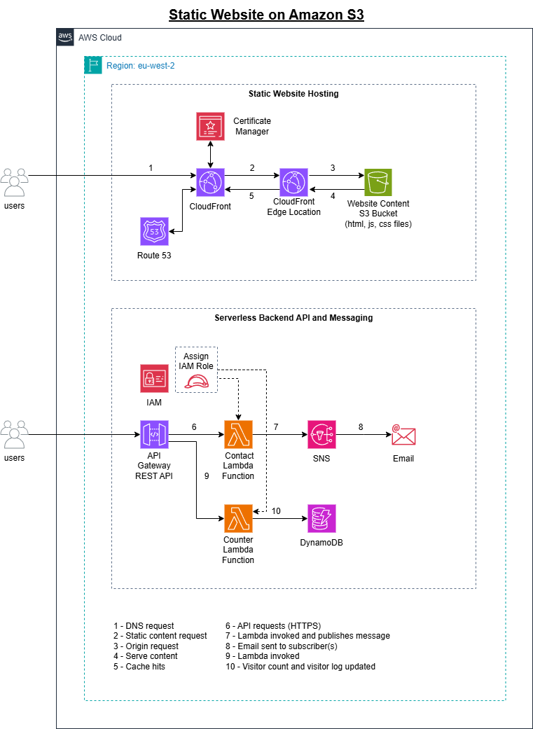

05 | AWS Services Used

Service | What it does in this project
COMPUTE
Lambda | Processes contact form and visitor tracking
STORAGE
S3 | Hosts the static website
NETWORKING & DELIVERY
CloudFront | Serves content from edge locations
Route 53 | Translates the domain to the CloudFront distribution
API Gateway | The front door for Lambda
DATABASE
DynamoDB | Live visitor counter and log
SECURITY & IAM
Certificate Manager | Provides a security certificate
IAM | Gives Lambda the required permissions to call DynamoDB and SNS via a managed baseline policy and an inline policy as an Execution Role
NOTIFICATIONS
SNS | Sends emails from the contact form

06 | Application Flow

Flow 1 – Visitor loads the website
- Step 1: Visitor types the domain name into their browser
- Step 2: Route 53 translates the domain to the CloudFront distribution
- Step 3: CloudFront checks its cache — serves from edge if cached
- Step 4: If not cached, CloudFront fetches from S3 via Origin Access Control
- Step 5: Browser loads the page and calls the visitor counter API
- Step 6: API Gateway triggers the visitor counter Lambda function
- Step 7: Lambda retrieves the current visitor count, adds one to it, and then update the counter on the page

Flow 2 – Visitor submits contact form
- Step 1: Visitor fills in the form and clicks Send
- Step 2: Browser sends a POST request to the API Gateway endpoint
- Step 3: API Gateway triggers the contact form Lambda function
- Step 4: Lambda reads the form data and validates it
- Step 5: Lambda calls SNS to send an email to the site owner
- Step 6: Lambda returns a success response — browser shows confirmation

07 | Security

Security control | How it is implemented in this project | Status
HTTPS / TLS encryption | CloudFront redirects HTTP to HTTPS.  All traffic encrypted in transit via TLS. | Implemented
Private S3 bucket | Block All Public Access enabled. Only CloudFront can access the bucket via Origin Access Control (OAC). | Implemented
IAM least privilege | Lambda execution role grants only DynamoDB read/write and SES send - no other permissions. | Implemented
No hardcoded credentials | No AWS keys in code. Lambda uses IAM execution role. Table names in environment variables. | Implemented
CORS configured | API Gateway CORS allows requests only from the application domain, not all origins. | Implemented
SSL Certificate | Free ACM certificate issued in us-east-1, auto-renewing, attached to CloudFront distribution. | Implemented

Known limitations / not implemented in this version
Rate limiting on the contact form API is not implemented in this version.
A production deployment would add AWS WAF rules to prevent spam.

08 | Cost Estimate

Service | Usage assumption | Free Tier cost/month | Production cost/month
S3 | 40 page views/month | £0.00 | £0.00
CloudFront | 50 https requests/month | £0.00 | £0.00
Route 53 | .com domain + Route 53 hosted zone | [N/A] | ~£1.00/month
Certificate Manager | 1 certificate | £0.00 | £0.00
Lambda | 100 requests/month | £0.00 | £0.00
DynamoDB | 0.01GB storage | £0.00 | £0.00
SNS | 50 requests/month | £0.00 | £0.00
API Gateway | 100 requests/month | £0.00 | £0.00
ESTIMATED MONTHLY TOTAL |  | £0.00 | £1.00/month

09 | Next Steps & Future Improvements

Planned improvements for the next version
Add AWS WAF to protect the API from spam and abuse.
Add CloudWatch dashboards for real-time monitoring.
Implement CI/CD via GitHub Actions for automatic deployment.
Add a blog section backed by DynamoDB.

GitHub repository link | Live project URL
https://github.com/stuartallan1981/stuart-allan | https://www.stuart-allan.com

